**IMAGE IDENTIFICATION AND RECOGNITION USING NOVEL HYBRID ARCHITECTURE DEVELOPMENT FOR SATELLITE IMAGES**

**Elamathy S 1 , Ridu Varshini.N 2**

1 2 UG Scholar, Department of Computer Science and Engineering, Panimalar Engineering College, Ch-123

***Abstract***— **Recent advances in deep learning made tasks such as Image and speech recognition possible. Deep Learning is a subset of Machine Learning Algorithms that is very good at recognizing patterns but typically requires a large number of data. The continuous innovation and development of satellite technology has brought the world closer together. At present, there are thousands of artificial satellites in the world, and the number of spacecraft working in orbit is increasing. With the constant exploration of outer space, there is inevitably a large quantity of space debris, e.g., lacquer, satellite debris. How to distinguish space targets of interested from the massive debris is a hot topic and of great significance. The effective separation of space targets and space debris can ensure the safe operation of on-orbit spacecraft. But, nowadays with the advancement of technology there is still a lag in predicting the space crafts and the related targets in an accurate manner. In this work we will be focusing on developing a novel hybrid architecture for determining the different types of satellite images, where four different kind of pre-processing techniques as well as two different optimization techniques will be used to increase the accuracy of the proposed hybrid model. The concept of network surgery will be used for implementing the hybrid algorithm development. Thus by this work we will be able to determine any kind of satellite images given as an input to the generated model. Thus, we propose a solution for the determination of spacecraft with the most accurate prediction by developing a novel architecture.**

***Index Terms*—Space situational awareness, novel hybrid architecture, recognition of spacecraft**

# INTRODUCTION

Modern life depends on space technology, including communications, media, commerce, and navigation. Enabling space technology are the thousands of space assets (satellites, space station, etc.) currently in orbit, which amount to trillions of dollars of investment. With space usage moded to increase rapidly, in part due to the participation of new state and private operators, the number of space assets will also grow quickly.

Greater space usage naturally leads to more “crowding” of the geocentric orbits by resident space objects (RSOs); these include the space assets that directly support the intended applications, as well as the orbital debris that occur as by-products of related space activities (e.g., launching, decommissioning or destruction of space assets). The increase in RSOs raises the potential of collision between space assets and debris and this has been identified as a pressing issue.

Achieving SSA is crucial towards alleviating the risk of space asset destruction due to collisions. The recognition of space targets utilizes various techniques to obtain their characteristics and information, determining the attributes, types, locations of the targets. However, most of them are based on artificial features , and their reliability is restricted by various conditions. For example, when the shape of the fragment is similar to the partial shape of the space target, they would not be distinguished easily due to the lack of deep semantic digging.

## Existing model for the recognition of spacecraft

The existing system focuses on effective optical detection of multiple man-made objects in the geostationary orbits. The system performs the optical detection from the optical images. Topological sweep is used for the multiple geostationary objects detection. It detects the geostationary objects from only the optical images. The accuracy is very poor compared to other state of the art methods.

## Our Contributions

In our work, we will be focusing on developing a novel architecture by effectively modifying the squeeze net for determining the different types of satellite images, where pre-processing technique as well as different optimization technique will be used to increase the accuracy of the proposed model. Thus, by this work we will be able to recognize any kind of satellite images given as an input to the generated model. A low weighted efficient model is been generated for use in the real time application.

# System architecture

Data is collected from the public source. As there are limited no of dataset available, and training requires a large number of data, data augmentation can help a lot. we increased the number of images through rotation, shifting, flipping, blurring, cropping, noising, and their combination. Thus the given data is augmented.

Later in preprocessing technique, Aspect aware algorithm is used and the image is converted to array. Then this preprocessed data will enter into the novel architecture for training. In this architecture the SqeezeNet algorithm is modified.SqueezeNet is the name of a deep neural network for computer vision and **it** is a convolutional neural network that employs design strategies to reduce the number of parameters, notably with the use of fire modules that "squeeze" parameters using 1x1 convolutions.

After the training, for the model generation, optimization and loss minimization is done. Once these processes are completed, evaluation and validation is done. We use COCO (Common Objects in Context) algorithm which is a large-scale object detection, segmentation, and captioning dataset.

Thus by using COCO algorithm space craft will be detected. Once the space craft is detected, the bounding boxes are drawn. Fig.1 shows the architecture diagram for image identification and recognition using the novel hybrid architecture.

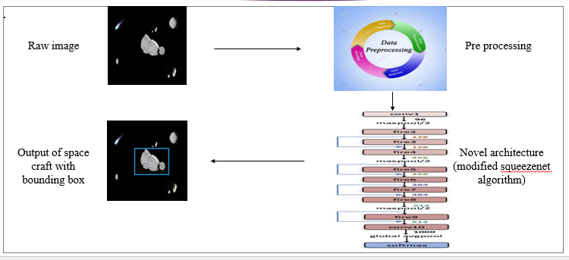

Fig. 1. Architecture Diagram

# Module Description

## Dataset collection

A data set is a collection of data. Deep Learning has become the go-to method for solving many challenging real-world problems. It’s definitely by far the best performing method for computer vision tasks. The image above showcases the power of deep learning for computer vision. With enough training, a deep network can segment and identify the “key points” of every person in the image. These deep learning machines that have been working so well need fuel lots of fuel; that fuel is data. The more **labelled data** available, the better our model performs. The idea of more data leading to better performance has even been explored at a large-scale by Google with a dataset of 300 Million images! When deploying a Deep Learning model in a real-world application, **data must be constantly fed**to continue improving its performance. And, in the deep learning era, data is very well arguably the most valuable resource

## Preprocessing data

In this work the preprocessing data module is used to resize the images. In deep Learning module the quality of the training data determines the quality of your model. The data you will encounter in practice will be not clean in most cases. It means the data will contain non-uniform data formats, missing values, outliers, and features with very different ranges. The data would not be ready to be used as training data for your model. For those reason, the data must be preprocessed in various ways.

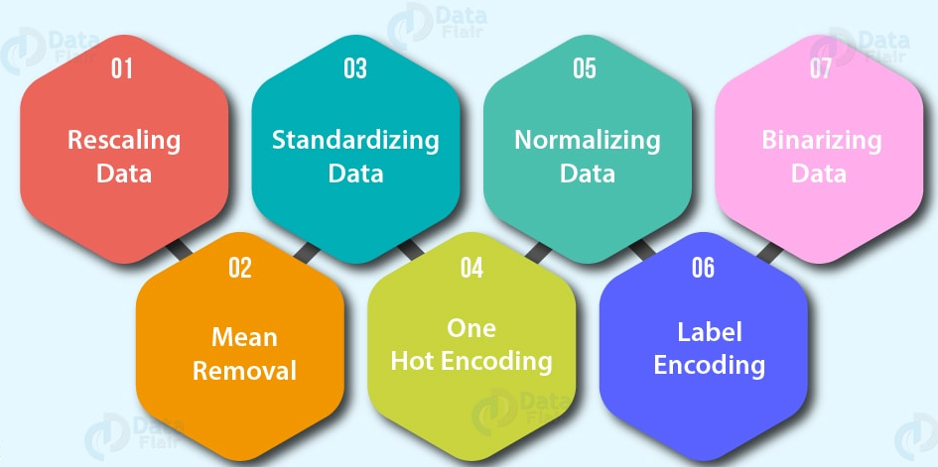

Fig 2. Preprocessing

## Data augmentation

Image data augmentation is perhaps the most well-known type of data augmentation and involves creating transformed versions of images in the training dataset that belong to the same class as the original image. Transforms include a range of operations from the field of image manipulation, such as shifts, flips, zooms, and much more. The intent is to expand the training dataset with new, plausible examples. This means, variations of the training set images that are likely to be seen by the model. Modern deep learning algorithms, such as the convolutional neural network, or CNN, can learn features that are invariant to their location in the image. Nevertheless, augmentation can further aid in this transform invariant approach to learning and can aid the model in learning features that are also invariant to transforms such as left-to-right to top-to-bottom ordering, light levels in photographs, and more. Image data augmentation is typically only applied to the training dataset, and not to the validation or test dataset. This is different from data preparation such as image resizing and pixel scaling; they must be performed consistently across all datasets that interact with the model.

## Training with novel architecture

In this work, we will be developing a novel architecture by effectively modifying the squeezenet architecture.

The main ideas of the novel architecture are:

1. Using 1x1(point-wise) filters to replace 3x3 filters, as the former only 1/9 of computation.
2. Using 1x1 filters as a bottleneck layer to reduce depth to reduce computation of the following 3x3 filters.
3. Downsample late to keep a big feature map.

The building brick of Novel architecture is called fire module, which contains two layers: a squeeze layer and an expand layer. A Novel architecture stackes a bunch of fire modules and a few pooling layers. The squeeze layer and expand layer keep the same feature map size, while the former reduce the depth to a smaller number, the later increase it. The squeezing (bottoleneck layer) and expansion behavior is common in neural architectures. Another common pattern is increasing depth while reducing feature map size to get high level abstract.

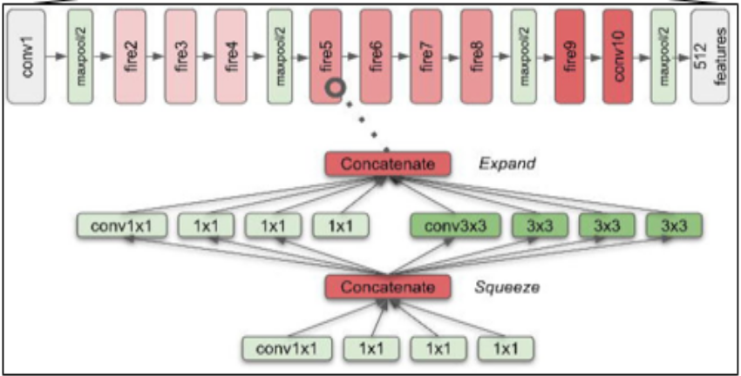

Fig. 3. SqueezeNet

As shown in the above chart, the squeeze module only contains 1x1 filters, which means it works like a fully-connected layer working on feature points in the same position. In other words, it doesn’t have the ability of spatial abstract. As its name says, one of its benefits is to reduce the depth of feature map. Reducing depth means the following 3x3 filters in the expand layer has fewer computation to do. It boosts the speed as a 3x3 filter need as 9 times computation as a 1x1 filter. By intuition, too much squeezing limits information flow; too few 3x3 filters limits space resolution.

## Object detection

Object detection is a process of finding all the possible instances of real-world objects, such as human faces, flowers, cars, etc. in images or videos, in real-time with utmost accuracy. The object detection technique uses derived features and learning algorithms to recognize all the occurrences of an object category.

Object detection technique helps in the recognition, detection, and localization of multiple visual instances of objects in an image or a video. It provides a much better understanding of the object as a whole, rather than just basic object classification.

This method can be used to count the number of instances of unique objects and mark their precise locations, along with labeling. With time, the performance of this process has also improved

To begin with, testing of the trained model, we can split our study into modules of implementation that is done. Dataset collection involves the process of collecting different space craft images for training. Various datasets were collected and one example among the collected dataset can be found below

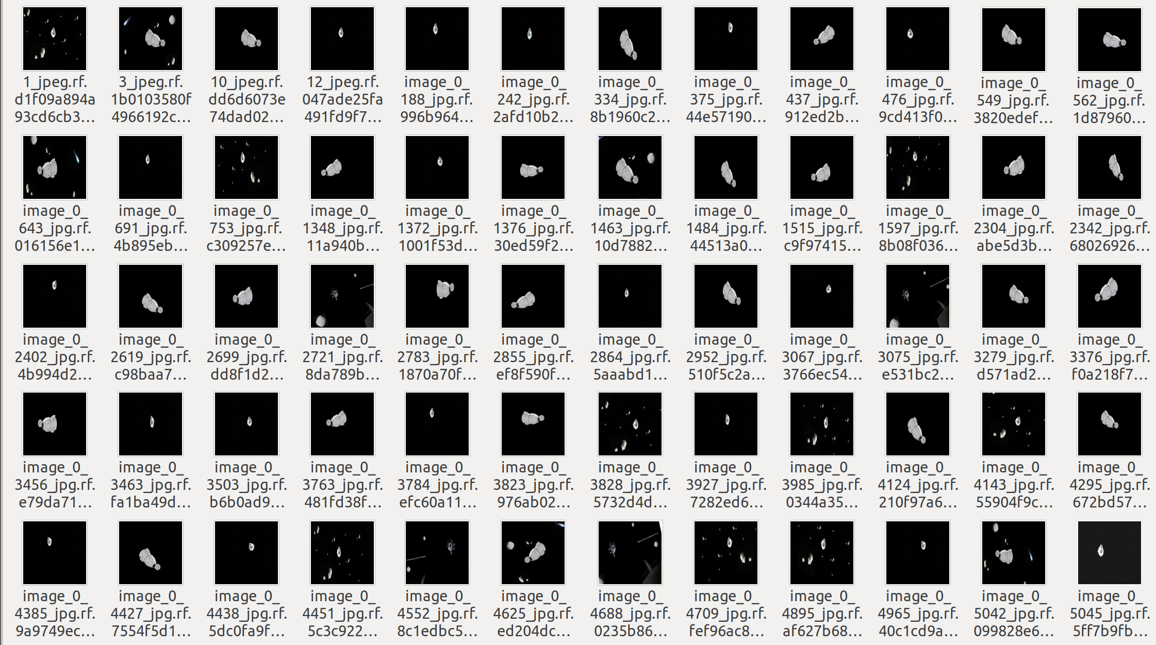

Fig. 4. Dataset collection

The next step is data pre-processing, in this phase the spacecraft images collected are set to standard resolution format. The below screenshot shows the image before preprocessing:

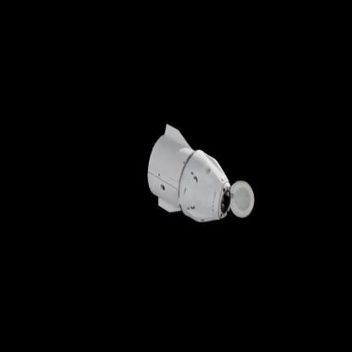

Fig. 5. Before pre-processing

The below screenshot shows the image after preprocessing:

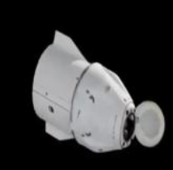

Fig. 6. After pre-processing

The next step is data augmentation which duplicates the collected data into many images so that the prediction percentage can be increased. A sample augmentation of an image can be seen in the below figure.The below screenshot shows the image before data augmentation:



Fig. 7. Image before data augmentation

The below screenshot shows the image after augmentation:

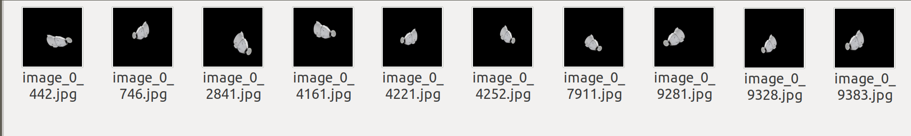

Fig. 8. Image after data augmentation

The next step is labelling of data where the spacecraft images collected are labelled according to their nature and the images are annotated and saved in xml format. The below screenshot shows the labelling of the dataset.

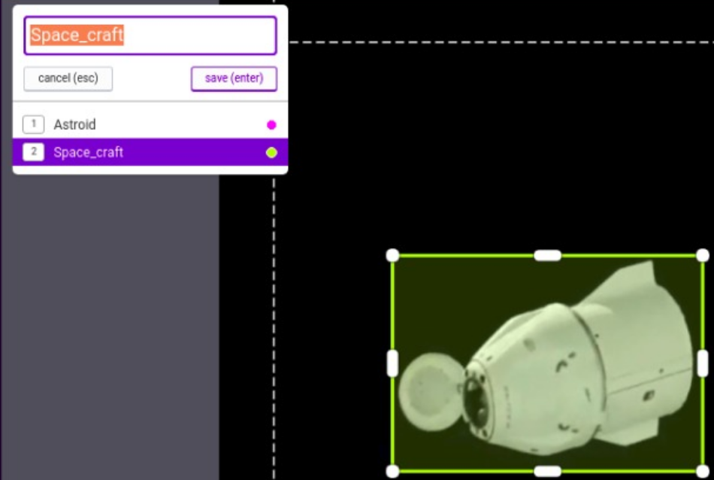

Fig. 9. Labelling of dataset

The below image shows the training process of the work using the available deep learning architectures:

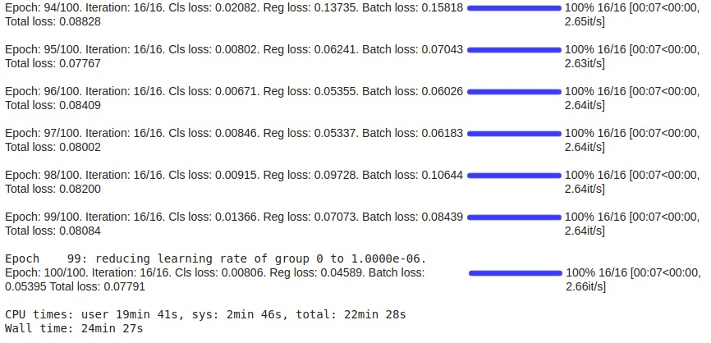

Fig. 10. Training process

In the training process, we can see the loss has got reduced in each step. The below image shows the reduction of losses.

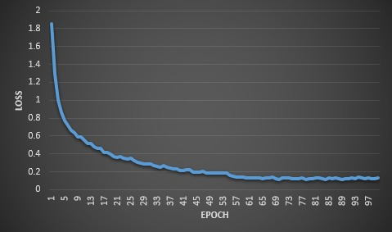

Fig.11.Reduction of losses

The below image shows the space craft detection of the work after training:

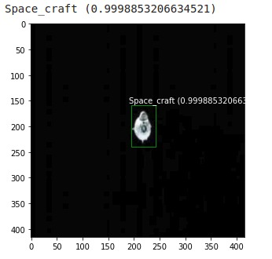

Fig. 12. Space craft detection

The below image shows the multiple space objects detection of the work after training:

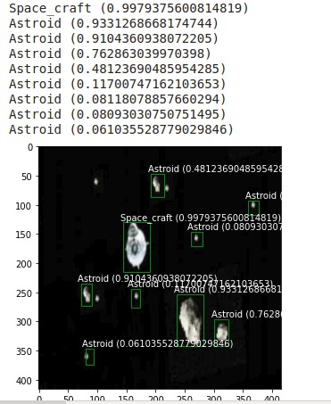

Fig. 13. Multiple space objects detection

Thus, from the above results and discussions it is clear that the work to effectively detect and identify space objects has been effectively implemented.

# CONCLUSION

This work is successfully implemented for effectively identifying the spacecrafts using the available deep learning approach. This work is very helpful in providing a cheap yet effective solution to detecting space crafts and space objects.

##### References

1. Lei Tao , Student Member, IEEE, Xue Jiang , Senior Member, IEEE, Xingzhao Liu , Member, IEEE, Zhou Li, and Zhixin Zhou,” Multiscale Supervised Kernel Dictionary Learning for SAR Target Recognition”,2020
2. Joon-Ho Lee, Hyun-Jin Moon, and So-Hee Jeong,” Numerically Efficient Determination of the Optimal Threshold in Natural Frequency-Based Radar Target Recognition”,2019
3. Jifang Pei , Student Member, IEEE, Yulin Huang, Member, IEEE, Weibo Huo, Yin Zhang , Member, IEEE, Jianyu Yang, Member, IEEE, and Tat-Soon Yeo, Fellow, IEEE,” SAR Automatic Target Recognition Based on Multiview Deep Learning Framework”,2017
4. Chunlei Huo, Member IEEE, Zhixin Zhou, Kun Ding, Chunhong Pan,” Online Target Recognition for Time-sensitive Space Information Networks”,2016
5. Xueru Bai , Member, IEEE, Xuening Zhou, Feng Zhang, Li Wang, Ruihang Xue , and Feng Zhou , Member, IEEE,” Robust Pol-ISAR Target Recognition Based on ST-MC-DCNN”,2018
6. Tan Wu, Xi Yang, Bin Song, Nannan Wang, Xinbo Gao, Liyang Kuang, Xiaoting Nan, Yuwen Chen, Dong Yang,” T-SCNN: A Two-Stage Convolutional Neural Network for Space Target Recognition”,2017
7. Lin Chen , Student Member, IEEE, Xue Jiang , Senior Member, IEEE, Zhou Li, Xingzhao Liu , Member, IEEE, and Zhixin Zhou,” Feature-Enhanced Speckle Reduction via Low-Rank and Space-Angle Continuity for Circular SAR Target Recognition”,2015
8. Jiemin Hu, Wei Wang, Qinglin Zhai, Jianping Ou, Ronghui Zhan, and Jun Zhang,” Global Scattering Center Extraction for Radar Targets using a Modified RANSAC Method”,201
9. Zhiqiang He , Huaitie Xiao, Chao Gao, Zhuangzhuang Tian, and Si-Wei Chen , Senior Member, IEEE,” Fusion of Sparse Model Based on Randomly Erased Image for SAR Occluded Target Recognition”,2016
10. Nasser M. Nasrabadi, Fellow, IEEE,” DeepTarget: An Automatic Target Recognition using Deep Convolutional Neural Networks”,2017
11. Haibin Duan, Senior Member, IEEE, and Lu Gan,” Elitist Chemical Reaction Optimization for Contour-Based Target Recognition in Aerial Images”,2018
12. Ming Liu , Shichao Chen , Jie Wu , Fugang Lu, Xili Wang, and Mengdao Xing, Member, IEEE,” SAR Target Configuration Recognition via Two-Stage Sparse Structure Representation”,2015
13. Lan Du, Senior Member, IEEE, Jian Chen, Jing Hu, Yang Li, Hua He,” Statistical Modeling with Label Constraint for Radar Target Recognition”,2016
14. Baiyuan Ding and Gongjian Wen,” Target Reconstruction Based on 3-D Scattering Center Model for Robust SAR ATR”,2019
15. Yao-tung tsou1 , yung-li hu2 , yennun huang3 , (fellow, ieee), and sy-yen kuo2 , (Fellow, IEEE), ” SFTopk: Secure Functional Top-k Query via Untrusted Data Storage”,2017